**APP Database**

## A few general comments:

* In contrast to the SOAR Village Database, the important thing with the APP Database is not so much the option to create queries through all the dossier but the function to create neat print out reports for each dossier. Examples of what the reports should look about are attached (cover sheet, initial consult, consult notes that are used so far for recording data)
* What we need to be able to generate from this data:
  + - * print the child’s data (about what’s in the word doc called “cover sheet”)
      * print the data from the initial consultation (word doc called “initial consult”
      * print consultation notes (word doc called “consult notes”)
      * generate list of things that need to be done
      * generate list with all children with the same diagnosis
* There needs to somehow/somewhere be a search function to have all children with the same diagnosis show up in a list.

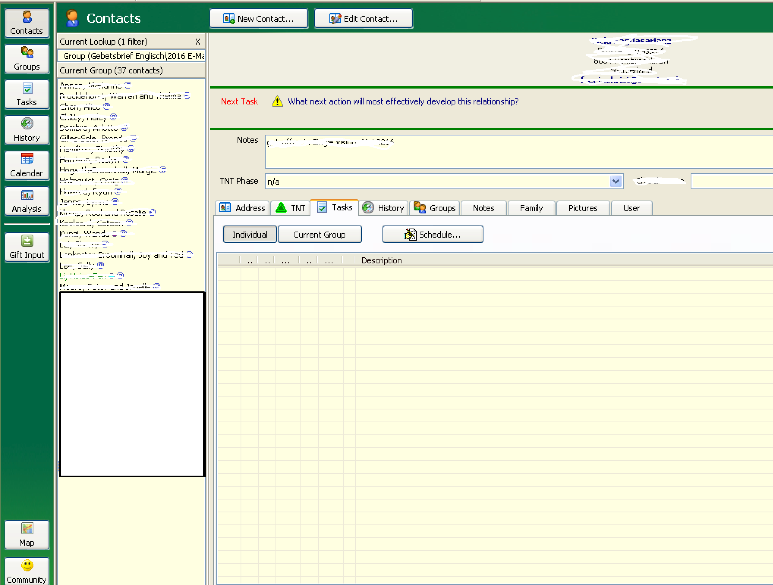

Child’s Details Section (incl. profile picture and Status field)

Tabs

List of all children (with filter and search function)

Menu bar

* Please format all dates like this: YYYY/MM/DD. (Nice to have but not essential: drop-down calendar to choose dates)
* We’re all not IT specialists, but we suppose it shouldn't be too hard to change the writing in the menu once the database programme is written. As we’re working in a bilingual environment, it would be great if we could later add Chinese translation to the menu so that our local workers can use it, too. We have some advanced users on the team who think they could possibly learn how to do that from you… ;-)
* Below, we are making some suggestions about how this database could be structured. All from a laymen’s perspective - if you (the experts!) have any better ideas, please ignore ours! ;-)

## Homepage

First page of the database should be as follows:

* Start-up default on the right should be a neutral page with a list of the reminders from the “Interactions” tab.
* To the left a list of all children (default: only the once with status “Active” – need filter/switch to show the others, too).
* There needs to be a button to create a new dossier and a search box where by typing in a name (either Chinese Name or Pinyin Name) the correspondent dossier will open up on the right, somewhat like the screen shot to the right from an Access based database (TntConnect is a Freeware programme that I use to organise my partners. It has great features but is somewhat cumbersome – we’d rather like our database simpler! ;-)).

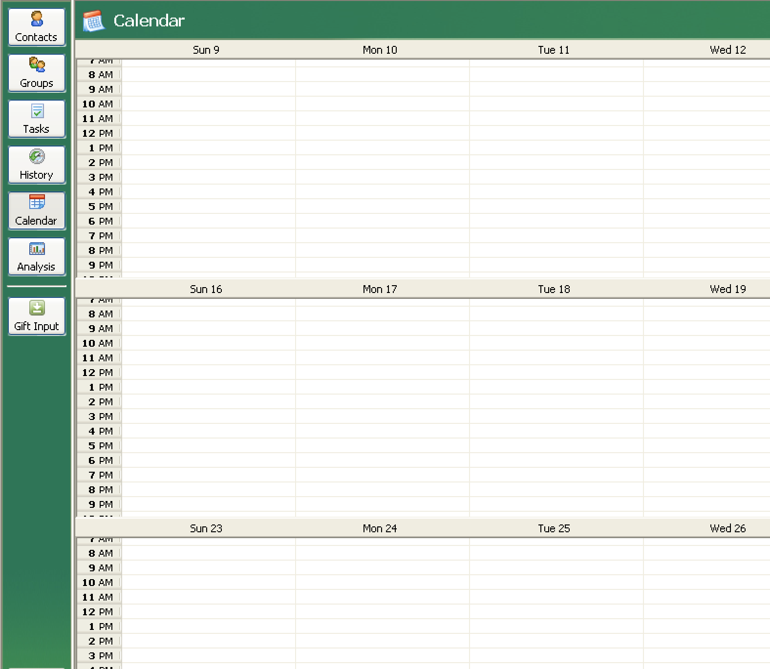

Calendar:

## Menu bar

It would be great if we could have a menu bar somewhat like the example of the screenshot on the next page. Some of the buttons/functions we would need on there are:

* Set reminders
* List of all reminders (“Tasks”?)
* Calendar (in which all appointments and dates set as reminders are visible – both future and history)

***Set reminders:***

Types (drop-down):

* Consultation SOAR Village

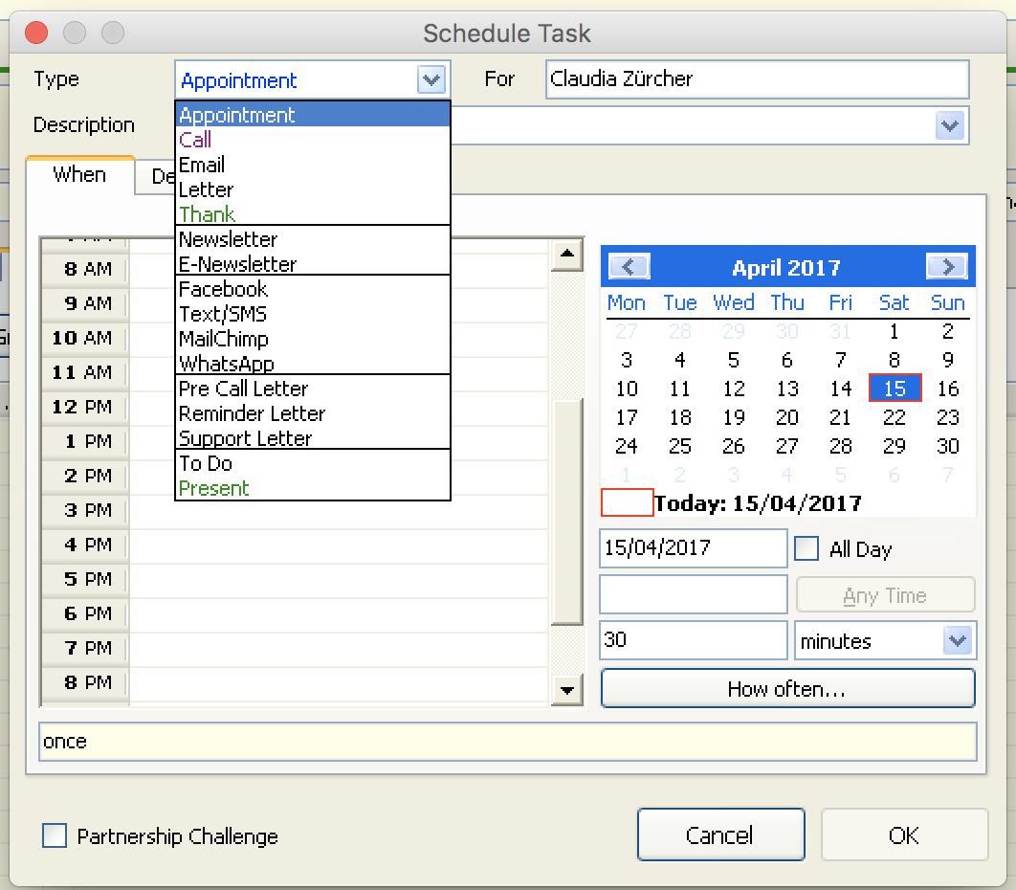

Set reminders:

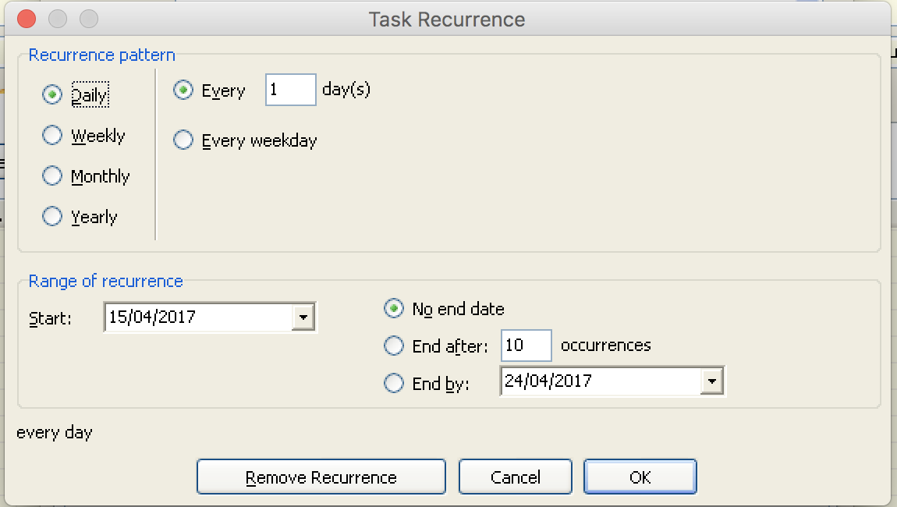

*Below is a screen shot of what pops up when “How often…” is pressed in the window to the right. However, we would like it simpler and maybe in one window if possible? The hourly calendar part is not needed, jus the monthly one and time could be specified in writing: “12:00”*

* Consultation FSS Center
* Home visit
* Phone call
* E-Mail
* WeChat
* To Do

(this is the same list as for the Interactions on the “Interactions” tab)

* Each reminder needs to be linked to a child’s dossier (ability to choose which child this is for)
* Ability to choose types (drop-down, see above)
* Ability to give a description (i.e. “book surgery”, “buy train ticket”, “call mother”, etc.)
* Need ability to set a date (and time) from either a calendar or a drop-down/tick box option:
  + - * tomorrow
      * 3 days from today
      * 1 week from today
      * 1 month from today
      * 6 months from today
      * 1 year from today
* Once the reminder is set, it should show in the child’s dossier on the “Interaction” tab in the “Tasks” section with a tick box next to it.
* A list of all reminders (from all children’s dossiers) should be accessible via a button on the home page menu bar
* Once the set date/time comes, there should be a pop-up alert on the start-up page of the database and if possible something that pops when the computer is started (maybe through Mac’s Notifications? We really don’t know if we’re asking for the moon here, sorry!)
* Once the box (on the “Interaction” tab list) is ticked, the tasks needs to move to the “Interaction” list on the same page. Please include the option to delete a task/interaction!

***List of all reminders:***

List all reminders for all children, sorted under headings according to their due dates:

* Today
* Tomorrow
* This week
* This month
* After 1 month

Each line should include the following data:

|  |  |  |  |  |  |
| --- | --- | --- | --- | --- | --- |
| **Date** | **Time (if inputted, otherwise leave blank)** | **Chinese Name** | **Pinyin Name** | **Type** | **Description** |
| 2017/04/14 |  | 王小军 | Wang Xiao Jun | Call | Call mother to arrange next consultation |
| 2017/04/20 | 10:00 | 张慧敏 | Zhang Hui Min | Consultation FSS Centre | OT appointment |
| 2017/04/21 |  | 李美丽 | Li Mei Li | To Do | Buy train tickets |

## Tabs

Each dossier has the child’s details at the top and then the following tabs underneath:

* Family Information
* Medical Information
* Projected Pathway
* Interactions

The following pages explain what each tab should contain. Tab headings are marked in green.

## Child’s Details (no need to show this heading – it’s just a working title for the top section of the dossier!)

*The top of a new dossier (above the tabs) should look something like this:*

*Please also include a profile picture upload (automatically resize the picture)*

|  |  |  |  |  |
| --- | --- | --- | --- | --- |
| Chinese Name: <text> | DOB: | Age: <number calculated from DOB> years | Diagnosis: | <status> |
| Pinyin Name: <text> | <date> | Primary: <linked from tab “Med. Info”> |
| Nickname: <text> | Sex: <drop-down> | Secondary: <linked from tab “Med. Info”> |
| Referred by: | <text> | | | |

*Diagnosis is inputted on “Medical Information” tab, but should be visible at the top of a dossier with the child’s data.*

*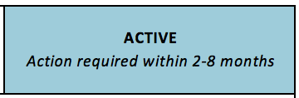The box on the top right indicates the status of the dossier. Options are:*

* ACTIVE (action within 2-8 months) green
* CURRENT (action within this month) orange
* IN SITU (on-going action required) blue
* RESOLVED pink

*Default for a new dossier is “Active”. Clicking on the box allows changing the status. The box then also changes the colour (corresponding colours noted to the right of the above list). To the right is a picture of what this should about look (colour’s wrong, though).*

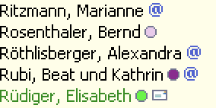

*It would be great if the name list on the homepage would have a little icon in the corresponding colour next to it to indicate the status of a child’s dossier (something like in the screenshot to the right).*

## Family Information

**Accompanying Family Members:**

|  |  |
| --- | --- |
| <drop-down> | <drop-down> |
| Name: <text> | Name: <text> |
| Phone: <text> | Phone: <text> |
| E-Mail: <text> | E-Mail: <text> |
| WeChat: <text> | WeChat: <text> |
| Address: <text> | Address: <text> |
| Notes: <text with scroll> | Notes: <text with scroll> |

***Drop-down options:***

* Mother
* Father
* Grandmother
* Grandfather
* Other

*There’s concern about cluttering, therefore don’t want a big “Notes” box in the above table but rather a scroll function and/or a way to click on to expand the full content of the box for easier perusal.*

**Other Significant Family Members:**

|  |  |
| --- | --- |
| Name: | Notes: |
| <text> | <text> |

*The above table needs the ability to add rows if needed for further family members. Again, to avoid cluttering, only the first line of the notes should be visible by default with an option to scroll and/or expand by clicking.*

Also, this tab needs a text field titled: “Family Dynamics Observed” to take notes of such.

## Medical Information

**Diagnosis:**

Primary: <drop-down> <text>

Secondary: <drop-down> <text>

Further Diagnosis: <text>

Reason for Referral: <text>

*Only the content of the drop-down of the primary and secondary diagnosis need to be linked with the top of the dossier (“Child’s details”) and the “Projected Pathway” tab. The content of the text box doesn’t need to be shown with the dossier header. Example:*

*Primary Diagnosis: Congenital Heart Defect Text box: Atrial Septal Defect*

*Only “Congenital Heart Defect” will be shown as the primary diagnosis on the dossier header and the pathway tab. Also, for searches for all children with a certain problem, the drop-down menu content is what should be considered relevant.*

***Drop-down options (same for primary and secondary; needs to be customizable!):***

* Autism
* Cleft Lip/ Cleft Palate
* CP
* Heart Defect
* Intestinal Malrotation
* Congenital Heart Defect
* Spina Bifida
* Down Syndrome
* Physical Abnormality
* PKU
* Intellectual Disability
* Seizures
* Umbilical Hernia / Gastroschisis
* ADHD

**History:**

Birth History:

Text box with scroll function

Medical History:

Text box with scroll function

**Medical Reports:**

*Function needed to upload scanned documents. List of uploaded documents visible, maybe something like this:*

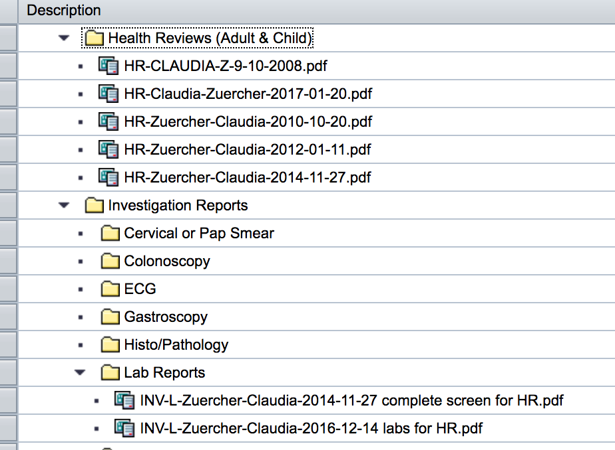

## Projected Pathway

At the top of this tab, please link from the “Medical Information” tab what’s chosen from the drop-down for “Primary and Secondary Diagnosis”

|  |  |  |  |
| --- | --- | --- | --- |
|  | Short Description | Details | Completion Date |
| Step 1 | <text> | <text> (only show the first couple of lines, expands on demand) | <date> |
| Step 2 |  |  |  |
|  |  |  |  |

* Ability needed to add as many steps as needed
* Way needed to mark (with colour) what step the child currently is at (maybe linked with the completion date of the previous step? If that field is filled in, the next step automatically becomes the “active” one?)

## Interactions

* When starting a new interaction, ask for the “Type” and depending on the choice, the form will be different (2 options, one for “Consultation SOAR Village”, “Consultation FSS Centre” and “Home Visit” and one for the rest of the drop-down options below).
* If choosing any of those first three options (Cons. SOAR vill., Cons. FSS Centre or Home Visit), there’s somewhere a tick box needed “Initial Consultation. It this box is ticked, the line visible in the list should change colour (maybe light pink?).
* Interactions will show up chronologically with the newest at the top. Because of the colour coding, it will be always easy to find the initial consultation.
* The list should only show the content of the table below. If one clicks on that particular entry, an extended form then becomes visible.
* Drop-down lists need to be customizable!

|  |  |  |
| --- | --- | --- |
| **Date** | **Type** | **Coordinator** |
| <date> | <drop-down> | <drop-down; 2 options: Tabatha Broxholme, Hou Aiping>  Expand |
| People present: | | <text; only first couple lines visible, rest shows on demand> |

*Here’s an example of what this list would look like:*

|  |  |  |
| --- | --- | --- |
| **Date** | **Type** | **Coordinator** |
| 2014/01/15 | Phone Call | Hou Aiping  Expand |
| People present: | | Mother |
| 2014/01/25 | Consultation FSS Center | Tabatha Broxholme  Expand |
| People present: | | Mother, father, maternal grandmother |
| 2014/02/10 | Consultation SOAR Village | Hou Aiping  Expand |
| People present: | | Mother, grandmother, Glenda Wilson (PT) |

***Drop-down options (needs to be customizable):***

* Consultation SOAR Village
* Consultation FSS Centre
* Home visit
* Phone call
* E-Mail
* WeChat
* To Do

*Form to be shown when ticking “Initial Consultation” box:*

|  |  |  |  |
| --- | --- | --- | --- |
| Current Concerns: | | <text> | |
| Developmental history and current ability: | | <text> | |
| **NOTES:** | | | **RECOMMENDATIONS:** |
| **Feeding:** | milk: | <tick box> | <text> |
|  | solids: | <tick box> |
|  | self-feeding: | <tick box> |
|  | texture preferences: | <text> |
| **Developmental and behavioural:** | <text> | | <text> |
| **OT:** | <text> | | <text> |
| **Sensory issues:** | <text> | | <text> |
| **Speech:** | <text> | | <text> |
| **Physical:** | Head control: | <tick box> | <text> |
|  | Rolling: | <tick box> |
|  | Sitting: | <tick box> |
|  | Standing: | <tick box> |
|  | Walking: | <tick box> |
|  | Gross motor: | <text> | <text> |
|  | Fine motor: | <text> | <text> |
|  | Weakness: | <text> | <text> |

*Form to be shown for “Consultation SOAR Village”, “Consultation FSS Centre” and “Home visit” (Bottom part below “NOTES & RECOMMENDATIONS” is the same as for initial consultation:*

|  |  |  |  |
| --- | --- | --- | --- |
| Developments since last visit: | | <text> | |
| Follow up on last visit’s recommendations: | | <text> | |
| Current concerns: | | <text> | |
| **NOTES:** | | | **RECOMMENDATIONS:** |
| **Feeding:** | milk: | <tick box> | <text> |
|  | solids: | <tick box> |
|  | self-feeding: | <tick box> |
|  | texture preferences: | <text> |
| **Developmental and behavioural:** | <text> | | <text> |
| **OT:** | <text> | | <text> |
| **Sensory issues:** | <text> | | <text> |
| **Speech:** | <text> | | <text> |
| **Physical:** | Head control: | <tick box> | <text> |
|  | Rolling: | <tick box> |
|  | Sitting: | <tick box> |
|  | Standing: | <tick box> |
|  | Walking: | <tick box> |
|  | Gross motor: | <text> | <text> |
|  | Fine motor: | <text> | <text> |
|  | Weakness: | <text> | <text> |

*If type is “Phone Call” or “To Do”, instead of the above forms, there is just a text field needed for notes.*